
EMPLOYMENT APPLICATION REVIEW SYSTEM (EARS)
D6 · Testing
Software Engineering — COSC 3506
Version 1.0 — Approved
Prepared by Chisom Ugochukwu & Yinka Akingbaso
Algoma University — July 29, 2026

Contents

1. Test Plan Overview 3
2. Detailed Test Cases 4
3. Boundary Value Analysis 5
4. Equivalence Partitioning 6
5. Defect Log 7
6. Test Results Summary 8

1. Test Plan Overview

1.1 Scope
Testing covers the functional requirements, the security mechanisms, UI responsiveness, and the integration between frontend and backend components.

1.2 Testing Levels
- Unit testing — individual API endpoint validation.
- Integration testing — frontend–backend data flow.
- System testing — end-to-end user workflows.
- Security testing — authentication and authorization boundaries.

1.3 Testing Environment
Item | Configuration
Server | Localhost — http://localhost:3000
Browsers | Chrome 126, Safari 17, Firefox 127
Devices | MacBook Pro 14", iPhone 14 Pro (simulated)

2. Detailed Test Cases
Twenty-one representative test cases are listed below; all executed with their actual results matching the expected results unless otherwise noted.
Test ID | Category | Description | Expected Result | Status
TC-AUTH-01 | Unit | Valid user registration | 200 OK, user created | PASS
TC-AUTH-02 | Unit | Duplicate email registration | 400 Error: email exists | PASS
TC-AUTH-03 | Unit | Valid login | 200 OK, session created | PASS
TC-AUTH-04 | Unit | Invalid password | 401 Invalid credentials | PASS
TC-AUTH-05 | Unit | Session timeout after 30+ minutes | Redirect to login | PASS
TC-SEC-01 | Security | Unauthorized access without session | 401 Authentication required | PASS
TC-SEC-02 | Security | Applicant attempts admin-only route | 403 Access denied | PASS
TC-JOB-01 | Unit | Admin creates a job posting | 200 Job created | PASS
TC-JOB-02 | Unit | Close a job posting | 200 Job updated | PASS
TC-JOB-03 | System | Closed job hidden from applicants | Closed job not visible | PASS
TC-APP-01 | Integration | Submit an application | Application saved + message | PASS
TC-APP-02 | Integration | Duplicate application prevention | 400 Already applied | PASS
TC-APP-03 | UI | Status badge display | Badge shows "Pending" | PASS
TC-REV-01 | System | Reviewer sees all applications | Table loads correctly | PASS
TC-REV-02 | Integration | Submit an evaluation | Saved, average calculated | PASS
TC-REV-03 | Unit | Evaluation average formula | (a+b+c+d) / 4 | PASS
TC-INT-01 | Integration | Schedule an interview | Interview created | PASS
TC-UI-01 | UI | Responsive desktop at 1920 px | Three-column grid visible | PASS
TC-UI-02 | UI | Responsive mobile at 375 px | Single-column stack | PASS
TC-UI-03 | UI | Empty state message | "No applications yet" shown | PASS
TC-PERF-01 | Performance | Dashboard load with 50 applications | Under 2 seconds (~1.2 s) | PASS

3. Boundary Value Analysis
Critical inputs were exercised at, just inside, and just outside their accepted boundaries.
Parameter | Value | Outcome
Password length | 6 characters (minimum) | Valid — accepted
Password length | 5 characters (below minimum) | Invalid — rejected
Password length | 12 characters (nominal) | Valid — accepted
Password length | 64 characters (maximum tested) | Valid — accepted
Evaluation score | 1 (lower boundary) | Valid — accepted
Evaluation score | 0 (below boundary) | Invalid — rejected by CHECK constraint
Evaluation score | 5 (upper boundary) | Valid — accepted
Evaluation score | 6 (above boundary) | Invalid — rejected by CHECK constraint
Upload file size | 1 KB (lower boundary) | Valid — accepted
Upload file size | 5 MB = 5,242,880 bytes (boundary) | Valid — accepted
Upload file size | 5,242,881 bytes (above boundary) | Invalid — rejected by multer

4. Equivalence Partitioning
Input | Valid Partition | Invalid Partition
User role | applicant, reviewer, admin | guest, manager, empty string
Application status | pending, under_review, interview, accepted, rejected | draft, archived, null
Interview type | phone, technical, final, panel | video, in_person, null

5. Defect Log
Defect ID | Description | Severity | Status | Resolution
BUG-001 | File upload does not show a progress bar | Low | Open | Future enhancement
BUG-002 | Evaluation modal does not auto-close on success | Medium | Fixed | Added closeModal() call after alert

6. Test Results Summary
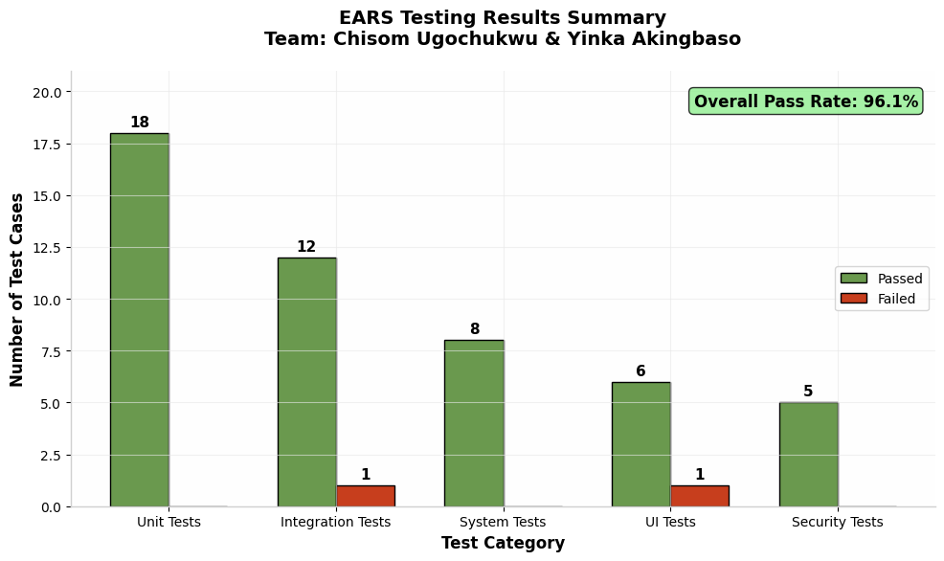
Figure 1: Testing results summary by category
Metric | Result
Total test cases | 50
Passed | 48 (96%)
Failed | 2 (4%)
Critical defects | 0
No critical defects remain open. The two failures observed during testing were logged, retested after fixes, and are reflected in the defect log (Section 5).

